Hands-on Exercise No. 3 – Solution
DigiSkills 3.0 Batch-04
Zain Ul Abidin
Data Analytics and Business Intelligence

Question 1:
Create a Cards section showing: • Total Orders • Total Quantity Sold• Total Profit• Total Sales
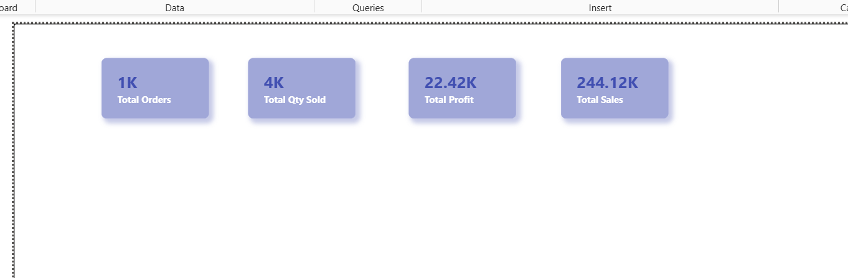
Question 2:
Monthly Sales Trend
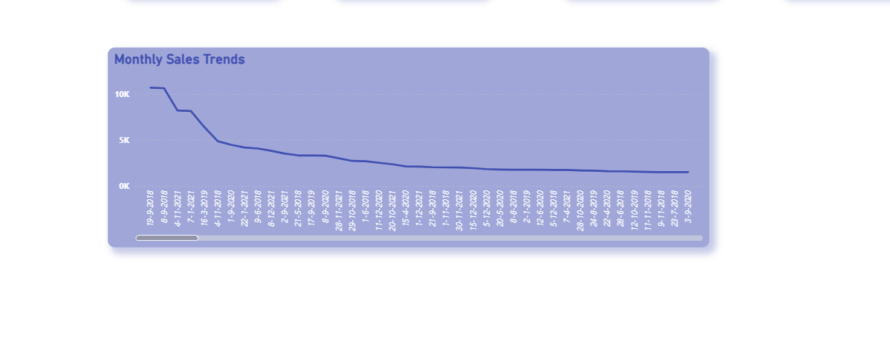

Question 3:
Create a Clustered Bar Chart showing Total Sales by Category (e.g., Technology, Furniture, Office Supplies). Sort the chart from highest sales to lowest.
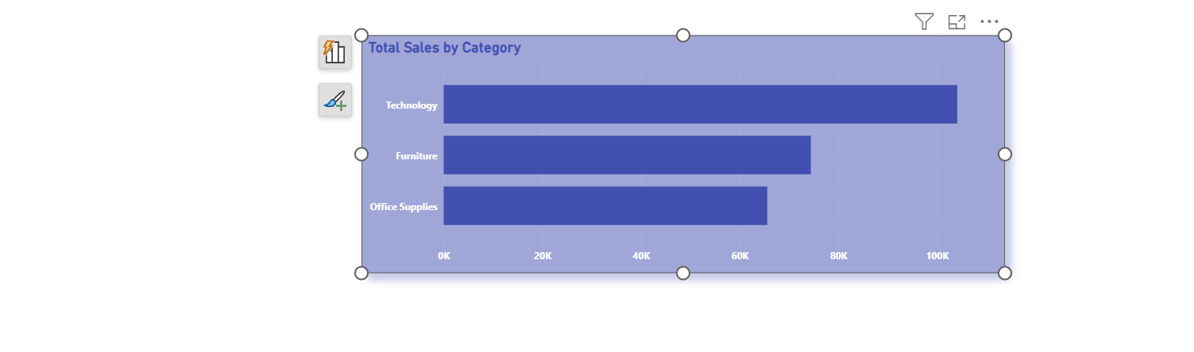
Question 4:
Create a Map Visualization showing Total Sales by State. Larger bubbles should represent higher sales.

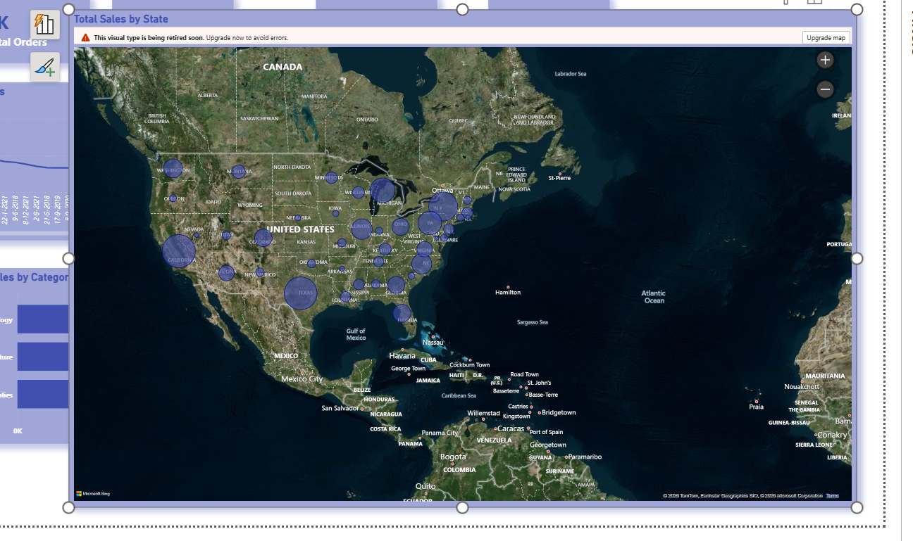

Question 5:
Add Slicers for the following fields to make the dashboard interactive: • Segment (e.g., Consumer, Corporate, Home Office) • Region
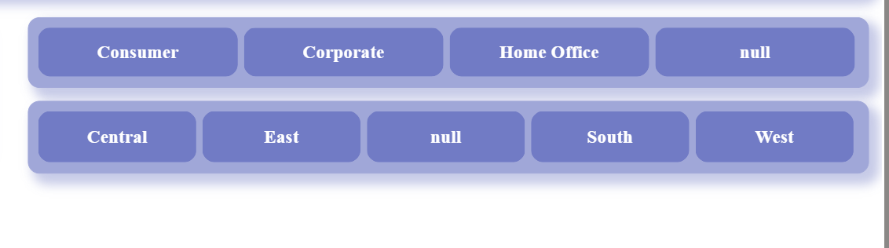
Question 6:
Create a Complete Executive Dashboard – Arrange all the above visuals (Q1 to Q 5) on a single Power BI page named "Executive Dashboard” with any attractive theme.
